CIRCUIT ANALYSIS
using
MATLAB

LAB # 12

Spring 2023
CSE103L Circuits & Systems-I Lab

Submitted by: # MUHAMMAD UMAR
Registration No. : 22PWCSE2148
Class Section: B

“On my honor, as student of University of Engineering and Technology, I have neither given nor received unauthorized assistance on this academic work.”

Student Signature: ______________

Submitted to:
Dr. Muniba Ashfaq
Month Day, Year (June 10, 2023)

Department of Computer Systems Engineering
University of Engineering and Technology, Peshawar

OBJETIVES:
In this lab we will solve for the matrix for previous 2 labs using Matlab.

MATLAB
MATLAB is a high-performance language for technical computing. It integrates computation, visualization, and programming in an easy-to-use environment where problems and solutions are expressed in familiar mathematical notation. Typical uses include: Math and computation.

SOLUTION:
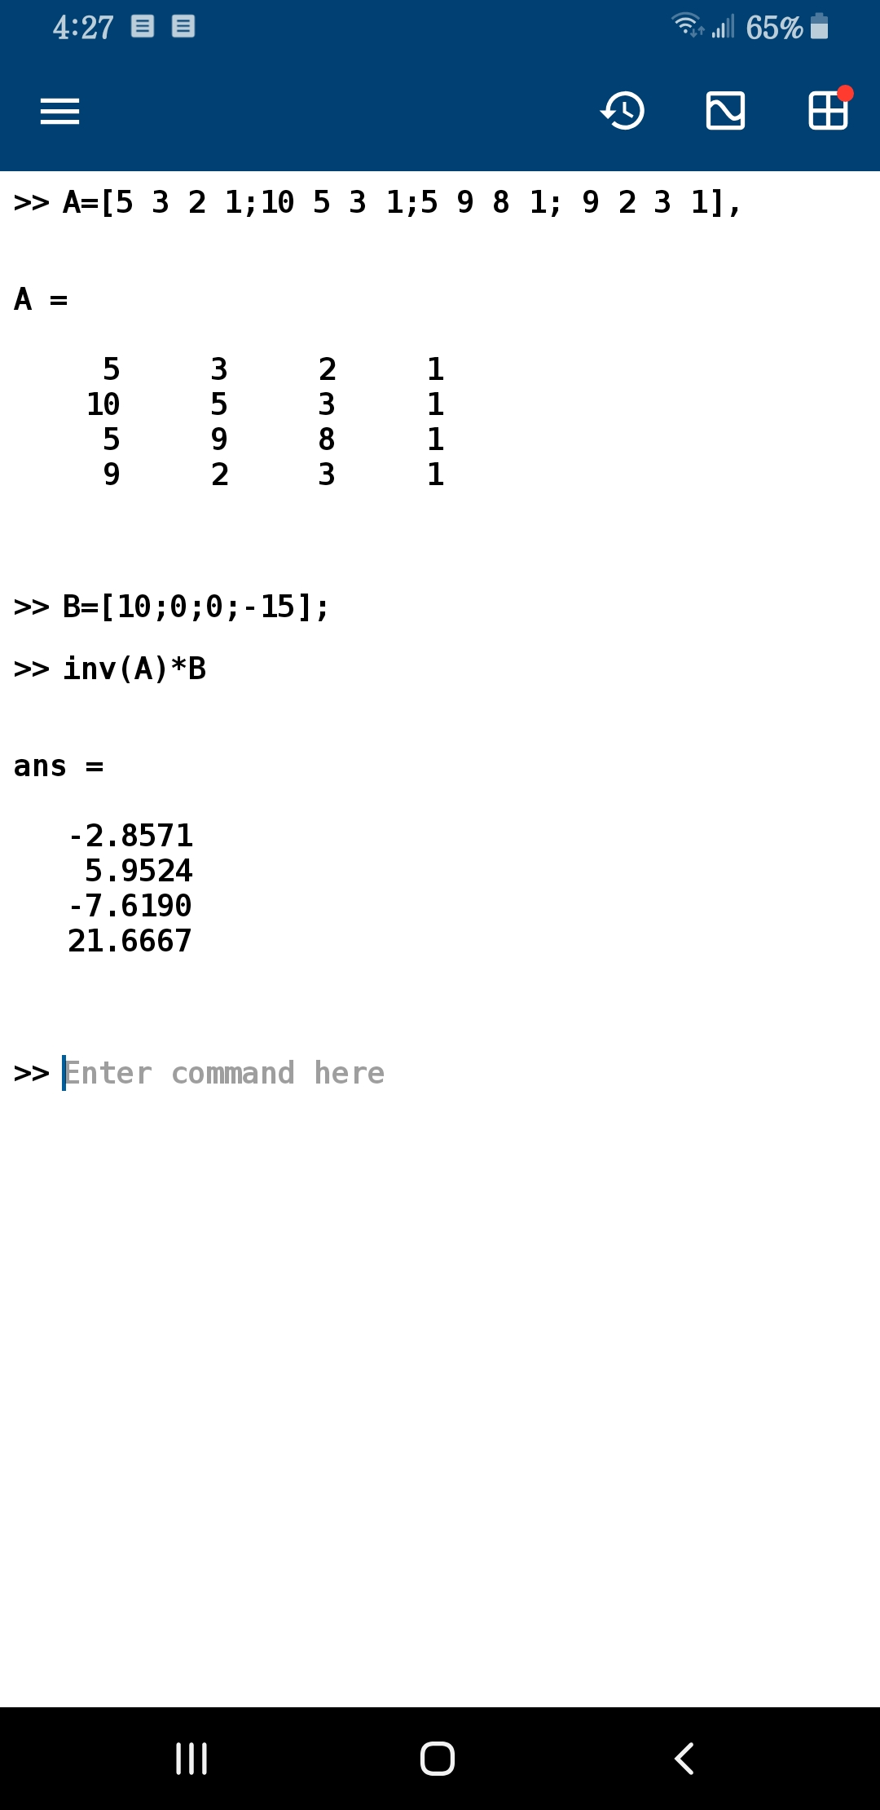

CONCLUSION:
We simply entered values for matrix A & B and entered a command for how to solve these matrices. We have used inverse method to solve A*B matrix and thus we found the 3 values

LAB RUBRICS: (Circuits & Systems-I Lab)

Criteria & Point  Assigned | Outstanding  4 | Acceptable  3 | Considerable  2 | Below Expectations  1
Attendance and Attentiveness in  Lab  PLO10 | Attended in proper  Time and attentive in Lab | Attended in proper  Time but not attentive in Lab | Attended late but attentive in Lab | Attended late not attentive in Lab
Equipment / Instruments Selection and Operation  PLO1,  PLO2,  PLO3,  PLO5, | Right selection and operation of appropriate equipment and instruments to perform experiment. | Right selection of appropriate equipment and instruments to perform experiment but with minor issues in operation | Needs guidance for right selection of appropriate equipment and instruments to perform experiment and to overcome errors in operation | Cannot appropriately select and operate equipment and instruments to perform experiment.
Result or Output/ Completion of target  in Lab  PLO9, | 100% target has  been completed and well  formatted. | 75% target has been  completed and well formatted. | 50% target has  been completed but not well formatted. | None of the  outputs are  correct
Overall, Knowledge  PLO10, | Demonstrates excellent  knowledge of lab | Demonstrates good  knowledge of lab | Has partial idea about the Lab and  procedure followed | Has poor idea about the Lab and  procedure followed
Attention to Lab Report  PLO4, | Submission of Lab Report in Proper Time i.e. in next day of lab., with proper  documentation. | Submission of Lab Report in proper time but not with proper  documentation. | Late Submission  with proper  documentation. | Late Submission Very poor  documentation

